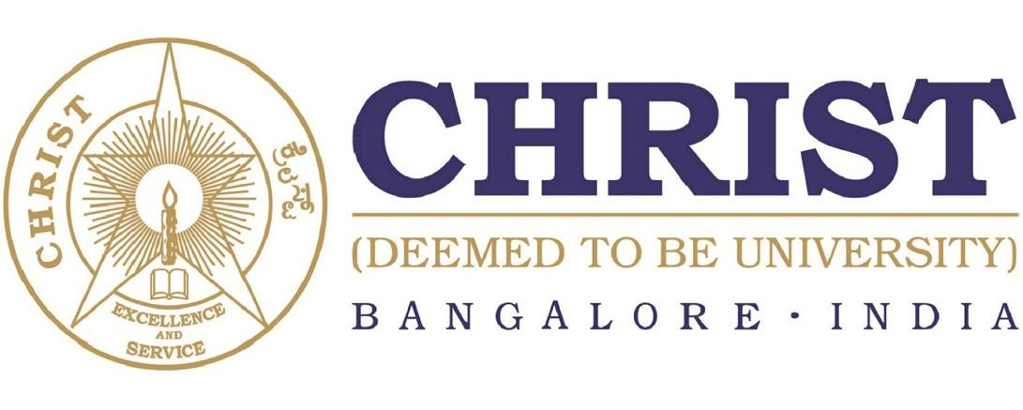

**DEPARTMENT OF**

**COMPUTER SCIENCE AND ENGINEERING**

**Data Base Management Systems**

**(CS331)**

B. Tech Degree – CSE

**School of Engineering and Technology,**

**CHRIST (Deemed to be University),**

**Kumbalagodu, Bengaluru-560 074**

December 2022



***Certificate***

*This is to certify that ………………………………………………. has successfully completed the record work for Database Management Systems –CS331P in partial fulfillment for the award of Bachelor of Technology in during the year 2021-2022.*

**Dr. K. Balachandran**

**HEAD OF DEPARTMENT FACULTY- IN CHARGE**

**EXAMINER 1:**

**EXAMINER 2:**

Name :

Register No. :

Examination Center :

Date of Examination :

**INDEX**

|  |  |  |  |  |  |
| --- | --- | --- | --- | --- | --- |
| **Exp. No** | **Date** | **Experiment Name** | **Page No** | **Marks** | **Signature** |
|  |  |  |  |  |  |
|  |  |  |  |  |  |
|  |  |  |  |  |  |
|  |  |  |  |  |  |
|  |  |  |  |  |  |
|  |  |  |  |  |  |
|  |  |  |  |  |  |
|  |  |  |  |  |  |
|  |  |  |  |  |  |
|  |  |  |  |  |  |
|  |  |  |  |  |  |
|  |  |  |  |  |  |